CHAPTER 16
The Markets for Labor and Other Factors of Production
- Chapter Summary
- Learning Objectives
- Chapter Outline
Teaching Tips/Topics for Discussion
- Solved Problems
- Solutions to Review Questions and Problems and Applications
1. Chapter Summary
Firms use factors of production to produce goods and services. A firm’s demand for factors of production is based on the underlying consumer demand for the good or service the factor is used to produce. To decide how many workers to hire, the firm compares the additional revenue it earns from hiring another worker to the increase in costs from paying the worker. The demand curve for labor is the relationship between the wage rate and the quantity of labor demanded. Other variables affect demand. If any variable other than the wage changes, the demand for labor will change. The five most important factors that cause demand to change are: increases in human capital, changes in technology, changes in the price of the product, changes in the quantity of other inputs, and changes in the number of firms in the market.
The supply curve is the relationship between the wage rate and the quantity of labor supplied. This relationship is generally positive but may become negative at high wages. Other variables affect supply. If any variable other than the wage rate changes, the labor supply will change. The three most important variables that will change the labor supply are: increases in population, changing demographics, and changing alternative employment opportunities. Equilibrium in the labor market occurs where the quantity of labor demanded equals the quantity supplied. Changes in demand and supply change the equilibrium wage rate and quantity of labor.
Differences in wages can be explained by differences in the marginal revenue products of workers. A worker with a high marginal revenue product will receive a higher wage than a worker with a low marginal revenue product. Compensating differentials can also explain wage differences; higher wages compensate workers for taking jobs that are dangerous or have other unpleasant characteristics. Discrimination on the basis of race, gender or some other irrelevant characteristic can also explain wage differences. A final factor that can explain wage differences is union membership. In the United States, workers who are members of unions earn higher wages than non-union members.
Personnel economics examines human resources issues such as how firms hire, train and promote workers and set wages and benefits. For example, personnel economics considers whether firms would be better off paying workers a certain hourly wage or a wage based on how much output workers produce.
The markets for capital and natural resources can be analyzed using the same approach used to analyze the market for labor. In all of these markets, the demand for the resource is derived from the demand for the good or service produced with the resource. The value of an additional unit of the resource used is its marginal revenue product. The quantity supplied is positively related to the price of a resource.
Individuals receive income equal to the marginal contribution to production from the factors of production they own, including labor. The more factors of production an individual owns, and the more productive those factors are, the higher the individual’s income will be.

2. Learning Objectives
Students should be able to:
- Explain how firms choose the profit-maximizing quantity of workers to employ.
- Explain how people choose the quantity of labor to supply.
- Explain how equilibrium wages are determined in labor markets.
- Use demand and supply analysis to explain how compensating differentials, discrimination, and labor unions cause wages to differ.
- Discuss the role personnel economics can play in helping firms deal with human resources issues.
- Show how equilibrium prices are determined in the markets for capital and natural resources.

3. Chapter Outline
Why Are the New York Mets Paying Carlos Beltran a $17 Million Salary?
1. The key to understanding why professional athletes often earn high salaries is to understand that wages are determined by the supply and demand for labor. People typically earn most of their income from wages and salaries, so they view the labor market as the most important market in which they participate.
►Teaching tips: An Inside Look at the end of this chapter examines the salaries of Division I college football coaches. Problems and Applications numbers 8 and 9 are related to the chapter opener. Class discussion of the salaries of star athletes will elicit varied opinions. Although the salaries earned by such star players as Carlos Beltran and Shaquille O’Neal (over $30 million for the 2004-05 National Basketball Association season) make headlines, many fans are less upset
about salaries earned by star players than they are with the salaries of lesser talents. During the 2004-5 NBA season the payroll of the champion San Antonio Spurs was $45 million. The payroll of the Detroit Pistons, their opponents in the NBA finals and the 2003-04 league champions, was just under $51 million. But the New York Knicks, a team that did not make the playoffs, paid their players nearly $100 million.
The Demand for Labor
1. The demand for labor is a derived demand.
- A derived demand is the demand for a factor of production that is derived from the demand for the good or service the factor produces.
  - The demand for labor is dependent on the amount of output produced and the additional revenue received from selling that output.
  - The marginal product of labor is the additional output a firm produces as a result of hiring one more worker.
  - Because of the law of diminishing returns, the marginal product of labor declines as a firm hires more workers.
- The marginal revenue product of labor is the change in the firm’s revenue as a result of hiring one more worker.
  - To decide how many workers to hire, a firm must compare the additional revenue it earns from hiring another worker to the increase in costs from paying the worker.
  - The marginal revenue product of labor curve is the demand curve for labor.
2. In constructing the demand curve for labor, all variables, except the wage rate, that affect the willingness of firms to demand labor are held constant.
- A change in the wage causes a change in the quantity of labor demanded.
- If any of the non-wage variables change, the demand curve will shift.
- The five most important non-wage factors are:
- Increases in human capital. Human capital refers to the accumulated training and skills that workers possess.
- Changes in technology. As new and better machinery is developed, workers become more productive and the labor demand curve shifts to the right.
- Changes in the price of the product. Higher prices increase the marginal revenue product and the labor demand curve shifts to the right.
- Changes in the quantity of other inputs. Workers are able to produce more if they have more machinery and other inputs.
- Changes in the number of firms in the market. If additional firms enter the market, the demand curve for labor will shift to the right.

►Teaching tips: Solved Problem 16-1 features an example of Sony Corporation choosing the number of workers to hire to make televisions. The related Problems and Applications #22 can be assigned for homework.
The Supply of Labor
1. The opportunity cost of leisure is the wage. The higher the wage one can earn from working, the higher the opportunity cost of leisure.
- Normally the labor supply curve is upward-sloping, but it is possible for the curve to be backward-bending at high wages.
- An increase in the wage raises the opportunity cost of leisure and causes a worker to devote more time to working. This is the substitution effect.
- Because leisure is a normal good, as the wage rises the income effect of a wage change will cause a worker to devote less time to working and more time to leisure.
- Whether a worker supplies more or less labor following a wage increase depends on whether the substitution effect is greater than the income effect.
2. The supply curve of labor is constructed holding constant all variables other than the wage.
- If any of the non-wage variables change, the supply curve will shift.
- The most important non-wage variables are:
- Increases in population.
- Changing demographics.
- Changing alternatives.
►Teaching tips: Students should be cautioned to not confuse the supply of labor with the supply of jobs. Some will believe that since they want jobs after graduation they represent the demand side of the market. Solved Problem 16-3 (below) can be assigned to ensure they do not make this error.
Equilibrium in the Labor Market
1. Demand and supply are used to determine equilibrium in the labor market. Demand and supply are also used to analyze changes in the equilibrium wage and the level of employment.
- Increases in labor productivity cause increases in the demand for labor and increases in the equilibrium wage and number of workers employed.
- An increase in the labor supply, if the labor demand is unchanged, will decrease the equilibrium wage and increase the number of workers employed.
►Teaching tips: Making the Connection 16-1 describes the signaling hypothesis in determining the value of a college education. Making the Connection 16-2 explains why wages did not fall in the U.S. as a result of the large increase in the population in the early 1900s due to immigration.
Explaining Differences in Wages
1. Differences in marginal revenue product are the most important factors in explaining differences in wages.
- The more productive a worker is and the higher the selling price of the worker’s output, the higher the wage the worker will receive.
- Compensating differentials can also explain wage differences. Compensating differentials are higher wages that compensate workers for unpleasant aspects of a job.
- In the United States, white males on average earn more than other groups. One possible explanation is economic discrimination.
- Economic discrimination refers to paying a person a lower wage or excluding a person from an occupation on the basis of an irrelevant characteristic such as race or gender.
- Excluding groups from certain jobs or paying one group more than another is illegal in the United States, but some employers ignore the law.
- Most economists believe that only a small amount of the gap between the wages of white males and other groups is due to discrimination. Most of the gap in wages is due to:
- Differences in education.
- Differences in experience.
- Differing preferences for jobs.
- Many economists argue that economic discrimination is no longer a major factor in labor markets in the United Sates because employers who discriminate pay an economic penalty.
2. Workers’ wages can differ depending on whether they are members of labor unions.
- A labor union is an organization of employees that has the legal right to bargain with employers about wages and working conditions.
- A smaller fraction of the U.S. labor force is unionized than in most other industrial countries.
- In the United States, union workers receive higher wages than workers who are not in unions.
►Teaching tips: Don’t Let This Happen To You! uses Adam Smith’s diamond-water example to warn students that prices and wages are determined at the margin. Making the Connection 16-3 explains how technological advances have raised the salaries of the highest-paid performers in sports and entertainment. Problems and Applications numbers 10 and 11 refer to the topics discussed in these features. Solved Problem 16-2 describes the arguments for and against comparable worth legislation. Problems and Applications #15 also concerns comparable worth. Comparable worth is a good topic for class discussion.
Personnel Economics
1. Personnel economics is the application of economic analysis to human resources issues.
- Personnel economics analyzes the link between differences in jobs and differences in the way workers are paid.
- Firms need to design compensation policies that take into account differences in the skill requirements of jobs, working environments, and the extent of interaction among workers.
- One compensation policy firms consider is whether workers will receive a certain wage or salary per week or month, or be paid a commission or piece-rate pay.
- Although a commission or piece-rate system of compensation can be more profitable than a salary system for some firms, other firms have good reasons to choose a salary system.
- Firms choose a salary system when:
- There is difficulty in measuring output and attributing output to a particular worker.
- There are concerns about output quality.
- Workers dislike the risk inherent in a piece-rate or commission compensation system.
►Teaching tips: Making the Connection 16-4 describes the successful introduction of a piece-rate system of compensation at the Safelite Glass Corporation. Solved Problem 16-5 (below) can be assigned to help students better understand why firms would choose a particular compensation system.
The Markets for Capital and Natural Resources
1. The markets for other factors of production are analyzed in much the same way as the market for labor.
- The demand for capital and the demand for natural resources are derived demands.
- Physical capital includes machinery, equipment and buildings.
- The marginal revenue product of capital curve is the demand for capital.
- The supply curve for capital goods is upward-sloping because the firms that produce capital goods face increasing marginal costs.
- The marginal revenue product curve for natural resources is the demand curve for natural resources.
- The supply curve for natural resources is usually upward-sloping.
- In some cases, the quantity of a natural resource is fixed and will not change as price changes.
- Economic rent (or pure rent) is the price of a factor of production that is in fixed supply.
2. Monopsony refers to a firm that is the sole buyer of a factor of production.
  - A monopsony restricts the quantity of a factor demanded to force down the price of a factor and increase its profits.
  - A firm with a monopsony in a labor market will hire fewer workers and pay lower wages than would be the case in a competitive market.
3. The marginal productivity theory of income distribution is the theory that the distribution of income is determined by the marginal productivity of the factors of production that individuals own.
- The more factors of production an individual owns, and the more productive those factors are, the higher the individual’s income will be.
►Teaching tips: Figures 16-11 and 16-12 illustrate equilibrium in the market for capital and natural resources. Problems and Applications #23 concerns the market for natural resources. Solved Problem 16-6 (below) concerns the market for natural resources.

4. Solved Problems
Chapter 16 includes two Solved Problems to support Learning Objectives 1 (Explain how firms choose the profit-maximizing quantity of workers to employ) and 4 (Use demand and supply analysis to explain how compensating differentials, discrimination, and labor unions cause wages to differ.) The following Solved Problems support this chapter’s other four learning objectives.

Solved Problem 16-3 Supports Learning Objective 2: Explain how people choose the quantity of labor to supply.

Dear Adam: I’m confused. Help!
The following letter was written to an advice column titled “Dear Adam.” The column provides online advice to college economics students who have difficulty understanding economics concepts.
Dear Adam:
I am a college microeconomics student from Santa Fe. My hometown passed a law in 2003 that raised the minimum wage for all businesses in the city with 25 or more workers. In 2004, the minimum wage was $8.50 and is scheduled to rise to $10.50 by 2004. My friends have expressed different opinions about this law but what I am confused about is the effect it has had on the market for jobs. A local business owner wrote a letter to the magazine City Journal complaining that the law “is driving existing businesses out of town.” If this is true, it means that the higher wage will reduce the quantity supplied of jobs. But we learned in my microeconomics class that the labor supply curve was upward-sloping!
After the New Mexico state court upheld the minimum wage ordinance, a lawyer who supported the law claimed that it will “benefit the low-wage workers of Sante Fe.” This statement implies that the quantity demanded of jobs will rise as the minimum wage rises; I thought the demand curve for labor was downward-sloping.
I have an exam in two weeks on the labor market. Help!
Yours truly,
Hopeless in Sante Fe

Sources: “Court Upholds Sante Fe Wage Ordinance,” Brennan Center for Justice, June 25, 2004.
http://www.brennancenter.org/. Ed Tinsley, “Atlas Shrugging in Sante Fe,” City Journal. August 15, 2003. http://www.frontpagemag.com/.

Write a reply to Hopeless in Sante Fe explaining:
- The labor supply curve for labor.
- The impact of an increase in the minimum wage on Sante Fe workers.
Solving the Problem:
Step 1: Review the chapter material. You may want to read The Supply of Labor, since this problem refers to the material in this section of the textbook, which begins on page 504.
Step 2: (a) Dear Hopeless:
You made a common mistake in believing the market for labor was a market for jobs. The labor supply curve is the relationship between the quantity supplied of labor – not jobs – and the price of labor, or the wage rate. Understand, too, that the demand for labor refers to business firms’ demand for workers, not jobs. It should make sense to you that the business owner you referred to believed that the increase in the wage firms have to pay for workers would reduce the quantity demanded (of workers, not jobs!).
Step 3: (b) P.S.
The increase in the minimum wage would increase the quantity supplied of workers since the opportunity cost of one hour of work is an hour spent doing something else. Let’s call this “something else” leisure since the opportunity cost of working will be different for different people. At $5.15, fewer people would choose to work, or would work fewer hours, than at a wage rate of $8.50 or $10.50. But this does not mean all who are willing to work will be able to find jobs. I am sure you learned in your course that a worker will be hired only if the marginal revenue product he or she produces per hour is greater than the wage rate. Good luck on your exam!
Yours truly,
Adam

Solved Problem 16-4 Supports Learning Objective 3: Explain how equilibrium wages are determined in labor markets.

Help Wanted: K-12 Teachers (Knowledge of Spanish a Plus)
A survey conducted by the American Federation of Teachers found that the average salary of K-12 teachers (kindergarten through 12th grade) in 2002-03 in the U.S. was $45,771. The same survey estimated the average beginning salary for K-12 teachers in 2002-03 was $29,564. Average salaries differ by region as well as grade level and subject area. For example, Spanish-speaking mathematics and science teachers can command higher than average salaries in the Southwest and Western states. Several factors have affected the market for K-12 teachers in the U.S. in the first decade of the 21st century. Among these factors are:
- Increased numbers of retirements of teachers who began their careers in the 1950s and 1960s when the “baby boom” generation increased the demand for teachers.
- Increased enrollments of K-12 students as children of baby boomers began to attend school.
- Government efforts to reduce student-teacher ratios resulted in more funding for local school districts.

Source: “Annual Survey of State Departments of Education 2002-03,” American Federation of Teachers. http://www.aft.org.salary/index.htm.

(a) Draw a demand and supply curve for beginning K-12 teachers for 2002-03. Assume that the equilibrium beginning salary is $30,000 and the equilibrium quantity was 200,000. This is about the number of new teachers hired annually.
(b) How is the market for new teachers different from the market for other resources?
(c) Explain how the three factors listed above will affect the market for beginning teachers.

Solving the Problem:
Step 1: Review the chapter material. Since this problem concerns the material in Equilibrium in the Labor Market , you may want to read this section of the textbook, which begins on page 507.
Step 2: (a) See the graph below. Note that the demand curve represents school or school district officials (for example, school board members) who determine how many teachers will be hired. The supply curve represents applicants for K-12 teacher positions. Most of these applicants will be undergraduate education majors, but some may be people who switch careers from private business or government to education. The salary measured on the vertical or price axis should be considered a combination of salary and benefits. Benefits, such as medical insurance, are an important part of teachers’ compensation.
Salary
(thousands)
Quantity of beginning teachers
(thousands)
$30
200
Supply
Demand
The Market for Beginning K-12
Teachers
2002-03
Step 3: Answer (b). Markets for teachers, especially public school teachers, are different in several ways from other resource markets. First, unlike private firms, schools do not seek to maximize profits. Second, the source of funding for teaching positions in public school systems is tax revenue. Voters may not approve requests for additional teaching positions and other budget items. This means that while a school district may want to hire more teachers (willingness), taxpayers may not provide the funds necessary to hire the additional teachers (ability). Thus the actual demand for beginning teachers will not increase (shift to right).
Step 4: Answer (c). Each of these factors should result in an increase in demand for beginning teachers. For example, assume that greater numbers of retired teachers result in an increase in the quantity demanded of beginning teachers to 220,000 at a salary of $30,000. There would be a new equilibrium salary and quantity of beginning teachers and a shortage at the former equilibrium salary of $30,000. There will be a tendency for salaries to rise but, as noted in Step 3, funding for teaching positions could be subject to budget approval on the part of voters.

Solved Problem 16-5 Supports Learning Objective 5: Discuss the role personnel economics can play in helping firms deal with human resources issues.

“Hey, you sewing jeans. Get outta my face!”

Making the Connection 16-4 described a study by Edward Lazear of the Safelite Glass Corporation. Worker productivity and profits both increased when the firm abandoned a straight-time pay system in favor of a piece-rate system. Lazear found different results for Levi Strauss when the clothing company changed its compensation scheme in the opposite direction.

Levi’s is a worker-oriented company. It had good intentions when the piecework system was abandoned in 1992. Under that system, individual workers performed single, specialized tasks and were paid according to the work they completed. Under the new system, groups of 10-35 workers shared tasks and were paid according to the work they completed…instead of motivating workers…it damaged morale and triggered corrosive infighting. Skilled workers were pitted against slower colleagues. Threats and insults become common…the quantity of pants produced per hour plunged in 1993 to 77 percent of pre-team levels…labor and overhead costs raced up 25 percent. It was a disaster.

But Lazear found that a team incentive approach worked very well for British Petrol and Exploration (BPE). A team incentive approach rewards workers based on the output produced by a group of workers. The firm has an oil field in Prudhoe Bay, Alaska, with about 300 workers. Six months after introducing its team bonus approach, productivity increased more than 12 percent.

Source: Edward P. Lazear. “Personnel Economics and Economic Approaches to Incentives.” The Hong Kong Centre for Economic Research Letters, vol. 61. September/October 2000.

- Why did the team incentive approach fail at Levi Strauss but was successful at BPE?
- Under what circumstances are piecework systems and team incentive approaches likely to be successful?

Solving the Problem:
Step 1: Review the chapter material. This problem concerns the material in Personnel Economics, so you may want to read this section of the textbook, which begins on page 520.
Step 2: Answer question (a). The team incentive approach failed at Levi Strauss because producing jeans does not require teamwork. As was true with production at Safelite, each task is easily performed by individual workers and can be monitored. When the team incentive approach was used, there was a tendency for some workers to be “free riders” – to not work very hard, let others do most of the work but still get paid the same. At BPE’s Prudhoe Bay, field output could not be produced by one worker. Teamwork at BPE was necessary to produce oil; team-based pay was effective because production was truly a team effort.
Step 3: Answer question (b). In summarizing the lessons learned from the experience of Levi Strauss and BPE, Lazear wrote: “For production workers, pay [based] on output is very effective. However, many firms are reluctant to tie compensation to tangible measures of output…It is easier to simply pay everybody the same…Team-based pay is only effective when production is truly a team effort. Often times, team incentives are weak and may cause resentment.”

Solved Problem 16-6 Supports Learning Objective 6: Show how equilibrium prices are determined in the markets for capital and natural resources.

Old King Coal
Energy consumers in the United States expressed concern in early 2005 in response to price increases of nearly 20 percent and projections of even higher price increases in 2006. But these consumers were managers of electric utilities who faced higher prices for coal. Although much of the oil consumed in the U.S. is imported, the 1,104 million short tons (a short ton, or metric ton, is equal to 2,000 lbs.) of coal consumed in 2004 were mined at home. Most of the coal was used by firms as a factor of production and most of these firms were electric utilities. In 2004, over 90 percent of the coal mined – 1,015 million short tons – was used to generate electricity. Since transportation is a large part of the cost of using coal, the price is typically stated as a delivered price. The average delivered price of coal paid by electric utilities in 2004 was $27.28 per short ton. Coal in usually not thought of as a clean energy source, but over 1/3 of the coal mined in the U.S. is from Wyoming’s Powder River Basin (PRB). Coal from this source is very low in sulfur. Since the 1990 amendments to the Clean Air Act, electric utilities have faced restrictions on the amount of sulfur dioxide they can emit. Higher coal prices were due, in part, to an increase in demand as consumers sought substitutes for higher priced oil. But demand increased more for PRB coal because of the increase in the price of sulfur dioxide emissions allowances. Utilities are allowed to emit one ton of sulfur dioxide for each allowance they hold but may buy additional allowances from other utilities (this market-based tradeable emissions allowances program was described in chapter 5). The prices for these allowances increased in 2005 as utilities used allowances saved from prior years. PRB coal is relatively inexpensive to mine, so despite the cost of moving PRB coal to the midwest and east, where most of the electric utilities are located the delivered price of low sulfur coal is very competitive with delivered prices of coal mined in Kentucky and West Virginia.
Sources: Matthew Dalton, “Price for Wyoming Coal Surges,” Casper Star Tribune. April 14, 2005.
Table 28. “U.S. Coal Consumption by End-Use Sector 1995-2005.” Department of Energy.
http://www.eia/gov/eneaf/coal/quarterly/html/.
- Show how the equilibrium price is determined in the market for coal.
- Describe the how the marginal revenue product of coal affects the equilibrium price.

Solving the Problem:
Step 1: Review the chapter material. This problem concerns the material in The Markets for Capital and Natural Resources, so you may want to read this section of the textbook, which begins on page 523.
Step 2: The graph shown below illustrates the market for coal in 2004. It assumes the average delivered price of coal is the equilibrium price and the quantity of coal consumed in 2004 is the equilibrium quantity. Demand and supply determine prices in resource markets just as they do in the markets for goods and services, but the demand for coal is a derived demand. Much of the demand for coal is because it is a source of energy used to power electric utilities. The graph includes a higher dashed demand curve. Due, in part, to higher prices for oil, a substitute energy source, the price of coal is likely to rise through 2005 and 2006.
Step 3: The marginal revenue product for coal is similar to the marginal revenue product for any natural resource. It is the change in a firm’s revenue as a result of employing one more unit of the resource. It is also the demand for the resource. Therefore, the demand curves in the graph represent the marginal revenue product for coal.

Demand - 2004
Price
Quantity
(millions of short tons)
$27.28
1,015

5. Solutions to Review Questions and Problems and Applications

Answers to Thinking Critically Questions

1. The demand for successful college football coaches has probably increased much faster than the demand for capable college professors. The development of television broadcasts has been particularly important. See the discussion in Making the Connection 16-3 on why the earnings of “superstars” have grown so rapidly.

2. The salary cap would create a shortage of college coaches, similar to the impact of the cap on electricians’ wages shown in Solved Problem 16-2. The most talented coaches would probably move to the National Football League. The big losers would be the coaches; but because of the nature of athletic contests – whenever one team wins, another team must lose – the overall appeal of the games to fans probably wouldn’t change very much.

Answers to Review Questions

1. The marginal product of labor is the additional output a firm produces as a result of hiring one more worker. The marginal revenue product of labor is the change in the firm’s revenue as a result of hiring one more worker.

2. The demand curve for labor is the marginal revenue product of labor, which equal the marginal product of labor times the marginal revenue from selling another unit. The MRP_{L} slopes downward because the marginal product of labor eventually diminishes – due to the law of diminishing returns.

3. The opportunity cost of leisure is the wage that could have been earned by working. The supply curve of labor usually slopes upward because the substitution effect is larger than the income effect. As the wage rate rises, the opportunity cost of leisure rises because time away from work becomes relatively more expensive, so people work more. However, as the wage rate increases, the individual’s purchasing power rises too, so he or she will want to buy more of all normal goods, including leisure. As the wage rate rises, the substitution effect leads individuals to want to work more and the income effect leads them to want to work less, but the substitution effect is often larger than the income effect, causing the labor supply curve to slope upward.

4. The most important factors that cause the demand curve for labor to shift are: 1) changes in human capital, 2) changes in technology, 3) changes in the quantity of other inputs, 4) changes in the price of the product, and (5) changes in the number of firms in the market. The first three change the marginal product of labor.

5. The most important factors that cause the supply curve of labor shift are: 1) changes in population, 2) changing demographics, and 3) changing alternatives to work in general or work within a particular sector of the economy.

6. In this case, the equilibrium wage will fall, as will equilibrium employment.
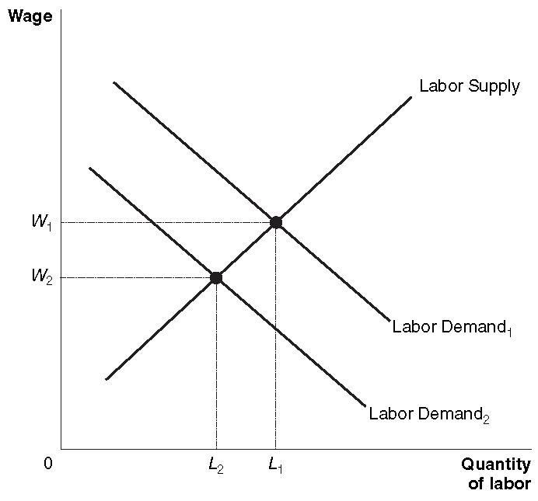
7. In this case, the equilibrium wage will rise, and equilibrium employment will fall.
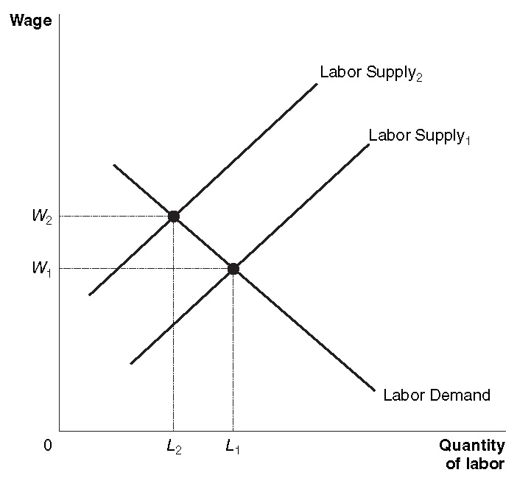
8. A compensating differential exists when a higher wage compensates workers for unpleasant aspects of the job. An example would be when workers need to be paid an extra $2 an hour to work in a job with a higher risk of injury.

9. Economic discrimination is paying a person a lower wage or excluding a person from an occupation on the basis of a characteristic that is irrelevant to productivity in the job, such as skin color. The fact that one group (right-handed men, for example) has higher average earnings than another group (left-handed men, for example) need not be evidence of economic discrimination. Before concluding that economic discrimination is the reason for the pay gap, one must adjust for differences in the productivity of the two groups. Because it is so hard (especially for someone who doesn’t supervise the workers) to measure productivity precisely, it is hard to determine whether differences in pay are due to differences in productivity or to discrimination.

10. The market undermines economic discrimination because employers who discriminate must pay higher wages than those who don’t discriminate.

11. Personnel economics is the application of economic analysis to human resource issues, such as compensation packages, promotions, training, and pensions. Many firms don’t use piece-rates (despite their advantages) because of difficulty in measuring individuals’ outputs, concerns about product quality, and workers’ aversion toward risk.

12. In equilibrium, the price of capital is determined by the intersection of the supply of capital curve and the demand for capital curve. Similarly, the equilibrium price of natural resources is determined by the intersection of the supply of natural resources curve and the demand for natural resources curve. The marginal productivity theory of income distribution concludes that each individual’s income is determined by the marginal productivity of the factors of production (such as labor, capital and natural resources) that the individual owns.

13. Economic rent is the price paid for a factor of production (for example land) that is in fixed supply. A monopsony is a market with only one buyer of a factor of production.

Answers to End of Chapter Problems and Applications

1. To maximize profits, Frank equates the wage to the marginal revenue product, so the marginal revenue product must be $8. Marginal revenue product = price x marginal product. So, in this case, marginal product = (marginal revenue product)/price = $8/$1.60 = 5 boxes per worker per hour.

2. As your wage rises you’ll want less leisure because the price of an hour of leisure is now higher (the substitution effect), but you’ll also want more leisure because you can now afford more leisure (the income effect). Your labor supply curve is vertical if this substitution effect is exactly the same size as the income effect.

3.

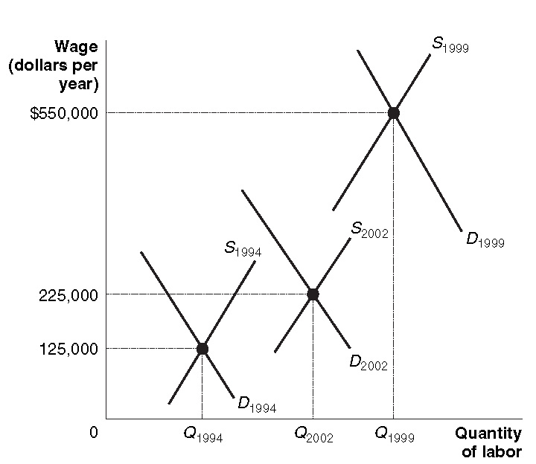

4. He feared that an increase in labor supply would lower the equilibrium wage. In fact, labor demand increased more than labor supply, and the equilibrium wage rose.

5. Not if labor demand increases by more than labor supply. (In fact, immigrants increase the labor supply, but they also buy products and thereby increase the labor demand, as well.)

6. The shift from Labor Supply₁ to Labor Supply₂ shows the effect of the plague on the quantity of sailors available at each wage. In the absence of government intervention, the wage would have risen from W₁ to W₂, and the quantity of sailors employed would have fallen from L₁ to L₂. The wage ceiling keeps the wage at W₁, but causes the quantity of sailors employed to fall all the way to L₃.

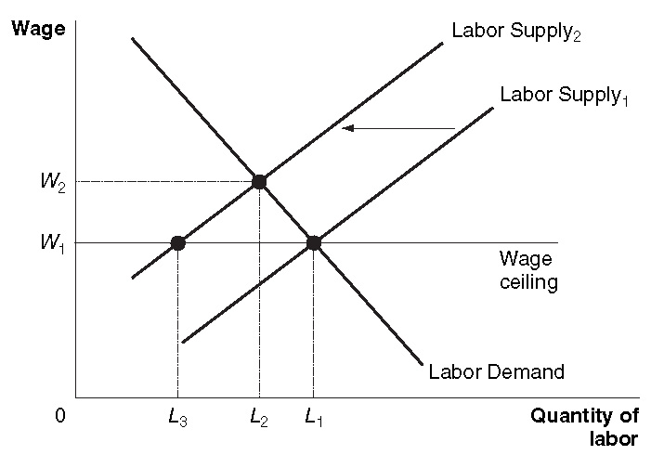

7. The economy will operate efficiently if workers are paid wages equal to their marginal revenue products. Workers with large marginal revenue products will receive more than workers with small marginal revenue products. Kinsley considers this outcome to be good for almost everyone, but others who care more about equality and less about efficiency may be more critical.

8. It would probably have very little effect. The salaries of baseball players would still be much greater than the salaries of college professors even if there were significantly more players on each team. With expanded rosters, the superstars would still have the highest marginal revenue products and would be paid over $10,000,000 per year. The new major leaguers wouldn’t get very much playing time, wouldn’t have high marginal revenue products, and would earn less than the league average – pulling down average pay somewhat, but not shrinking the gap between the superstars and college professors.

9. The marginal revenue product of major league baseball players is much higher than the marginal revenue product of college professors, even though the price of a college education is much greater than the price of a ticket to a baseball game.

10. Alex Rodriguez’s marginal revenue product – how much extra revenue he pulls in for his employer – is obviously much higher than the marginal revenue product of this fan’s boss. Rodriguez’s high pay is justified in an important sense because fans are willing to pay so much to see a winning Major League Baseball team. Complaints about high salaries for professional athletes amount to complaints that fan are willing to pay too much to view games. If A-Rod were paid less, the big winner would be his employer, the New York Yankees.

11. The increase in the relative incomes of superstars is mainly due to technological advances. For instance, the spread of cable television has greatly increased the number of potential viewers of basketball games. But many of those viewers will watch only if their team is winning. This increases the value to the owners of basketball teams of winning games and, therefore, increases the marginal revenue product of the best basketball players and the salaries they can earn. The difference between the marginal revenue products of the best auto mechanics and the marginal revenue products of average automobile mechanics is much smaller. A superstar automobile mechanic can only repair one car at a time, but a superstar athlete can perform for millions of fans simultaneously.

12. The people who run the tennis tournaments in which the Williams sisters play sell tickets and the right to broadcast the tournaments over television. So, the concept of marginal revenue product is just as important in explaining their earnings as it is in explaining the earnings of baseball players.

13. Before the passage of workers’ compensation laws, workers in hazardous industries such as coal and lumber had been receiving compensating differentials. After the passage of the laws, these compensating differentials declined, reducing the workers’ wages.

14. If economic discrimination were rampant against minority groups it would be unlikely that Asian males would earn more than white males. However, it is important not to use average wages to assess whether or not discrimination occurs. Differences in productivity are probably the main factor determining differences in wages. Economic discrimination occurs when someone is paid less due to an irrelevant characteristic which isn’t related to productivity.

15. a. 7,000 sanitary engineers at a wage of $600 per week.
b. 90,000 receptionists at a wage of $400 per week.
c. The marginal revenue products of the two types of workers may differ. There may also be a compensating differential because the work of sanitary engineers is dirty and unpleasant.
d. 6,000 sanitary engineers and 8,000 receptionists.

16. Without comparable worth legislation, the equilibrium wage for economics professors is $70,000 per year and the equilibrium number of economics professors hired is L₁. Setting the wage for economics professors below equilibrium at $60,000, reduces the number who are willing to work in this occupation from L₁ to L₂, but increases the number demanded by employers from L₁ to L₃. The result is a shortage of economics professors equal to L₃ – L₂, as shown in the graph. Without comparable worth legislation, the equilibrium wage for English professors is $50,000 and the equilibrium number hired is L₁. Setting the wage for English professors above equilibrium at $60,000, increases the number who want to work in this occupation from L₁ to L₃, but reduces the number demanded by employers from L₁ to L₂. The result is a surplus of English professors equal to L₃ – L₂, as shown in the graph.

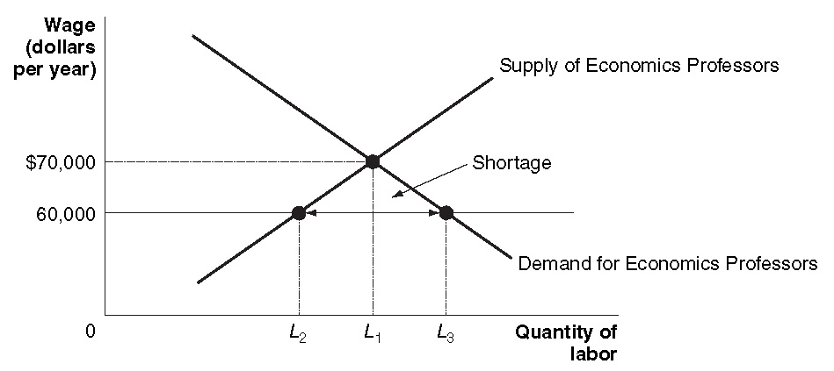
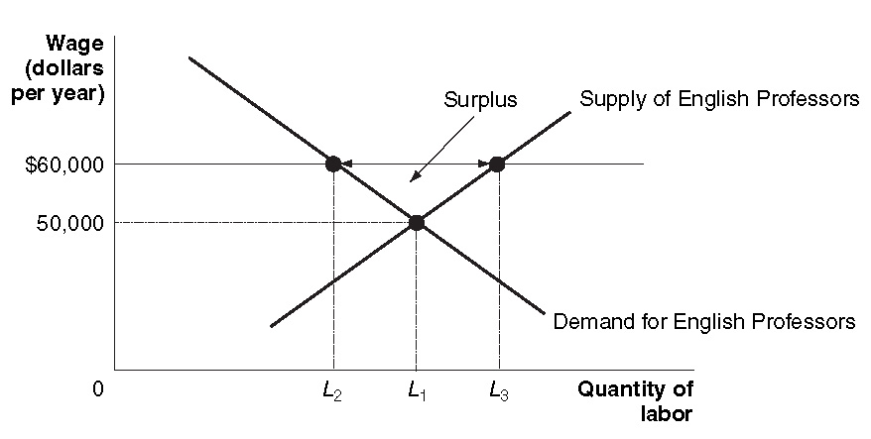

17. It is likely that these women ended up with less education than they would have if they had known they would be in labor force. As a result, their earnings were lower than they would have been if they had correctly predicted the future.

18. Complete exclusion from an occupation is a sign that employees are the discriminators, rather than employers. In occupations from which blacks were not excluded, equal pay for equal work was almost inevitable, especially in a very competitive market with many employers, such as agriculture. Employers who tried to pay black workers less would lose many of them to employers who didn’t discriminate and would be at a competitive disadvantage. In addition, paying workers doing the same jobs different wages may have reduced morale and productivity.

19. It isn’t likely because workers who found the job acceptable with the previous minimum now have an economic incentive to produce more. If they had wanted to produce less, it is likely they already would have found a job that required less work for a lower wage.

20. It will be higher under a piece-rate system, because the workers are willing to put in a greater effort to earn more.

21. Previously, salespeople had an incentive to sell more inexpensive tires, which were probably less profitable for Goodyear. In addition, because they were compensated on the basis of the quantity of tires sold, they had an incentive to reduce the price to sell more tires, even if this reduced Goodyear’s profits.

22. a.
Number of Machines | Output of Pins (Boxes per Week) | Marginal Product of Capital | Product Price  (Dollars per Box) | Total Revenue | Marginal Revenue Product of Capital | Rental Cost per Machine | Additional Profit from Renting One Additional Machine
0 | 0 | — | $100 | 0 | — | $550 | —
1 | 12 | 12 | 100 | $1200 | $1200 | 550 | $650
2 | 21 | 9 | 100 | 2100 | 900 | 550 | 350
3 | 28 | 7 | 100 | 2800 | 700 | 550 | 150
4 | 34 | 6 | 100 | 3400 | 600 | 550 | 50
5 | 39 | 5 | 100 | 3900 | 500 | 550 | –50
6 | 43 | 4 | 100 | 4300 | 400 | 550 | –150

Adam should rent 4 machines.

b. The demand curve for capital curve equals the marginal revenue product of capital.

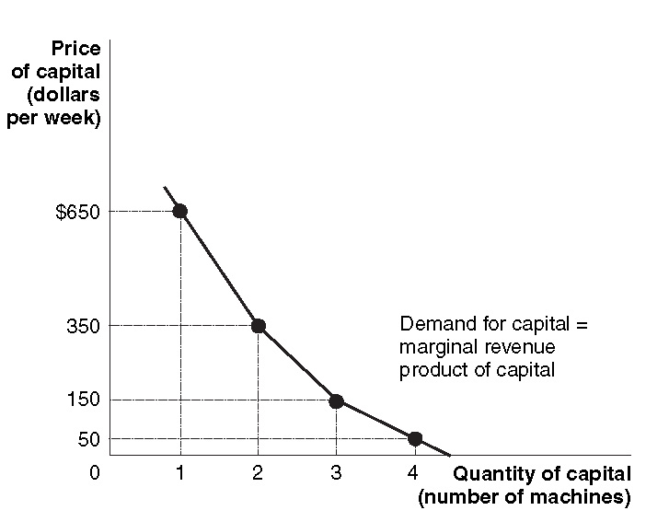

23. As the figure shows, the only way that the prices of natural resource won’t rise is if the supply of natural resources has shifted to the right at least as much as the demand for natural resources has shifted to the right. Paradoxically, even though we continue to use up natural resources, the supplies of most of them have continued to rise. The supply of natural resources has as much to do with the cost of finding, extracting and processing the natural resources as with their mere existence. Natural resources are a gift of nature, but it often takes a lot of effort to unwrap the gift, and we’ve gotten better and better at doing so over time.

